**“Extended Kalman Filter”**

**A Project Report**

**Submitted by**

**ADITEE**

**in the partial fulfilment for the award of the degree**

**Of**

**B.TECH**

**Information Technology**

By

**Aditee**

**Govt Women’s Engineering College Ajmer, Rajasthan**

**Submitted to**



**iDEX, Defence Innovation Organisation**

**Ministry of Defence**

**Government of India**

**June,2023**

This page is left intentionally blank

**Abstract**

**100 -150 words**

**An abstract may have the following five pieces:**

1. Introduction-

The Kalman filter has several applications in technology. Some common applications are: **Guidance and navigation of vehicles**, particularly aircraft and spacecraft. Robotic motion planning and trajectory adjustment. Position awareness radar sensors for advanced driver assistance systems (ADAS) in autonomous vehicles.

1. Problem Statement/Requirement –

Study extended Kalman filter and its implementation in any language.

Also, find the related use cases for the same-

For [statistics](https://en.wikipedia.org/wiki/Statistics) and [control theory](https://en.wikipedia.org/wiki/Control_theory), **Kalman filtering**, also known as **linear quadratic estimation** (**LQE**), is an [algorithm](https://en.wikipedia.org/wiki/Algorithm) that uses a series of measurements observed over time, including [statistical noise](https://en.wikipedia.org/wiki/Statistical_noise) and other inaccuracies, and produces estimates of unknown variables that tend to be more accurate than those based on a single measurement alone, by estimating a [joint probability distribution](https://en.wikipedia.org/wiki/Joint_probability_distribution) over the variables for each timeframe.

1. Procedures-

Started with Kalman filter introduction, example and then implementations in Python.-

The Kalman filter is a uni-modal, recursive estimator. Only the estimated state from the previous time step and current measurement is required to make a prediction for the current state. Each time step, the state transition matrix moves the state and process matrix based on the current position and velocity, estimating a new position/velocity as well as new covariance.

From there, the Kalman Gain is calculated, along with the observed data. The update process involves using the Kalman in conjunction with the previous estimate and new observed data to update the state variable towards a belief that’s somewhere between the prediction and measurement. The process covariance is also updated based on the Kalman gain. These updates are then used for the next round of predictions.

1. Results-

Study about Kalman filter in the language Python.

1. Conclusions- With Kalman filter we can mitigate the uncertainty by combining the information we do have with a distribution that we fell more confident in

Acknowledgments

The journey has started as a student towards the professional life with the main aim in mind to learn the practical aspects of life and it does a memorable experience also help me to come up with my flying colors.

No work can be completed without other help or contribution the preparation of the presentation of this humble work encompasses the immense and ultimate unlimited help and sound through innumerable people.

My special thanks to **iDEX, Defence Innovation Organisation Ministry of Defence Government of India** for providing me this opportunity to associate myself with them for my training with( Sagar Defence Engineering Pvt. Ltd. Mumbai) and also like to express my sincere gratitude to them for providing me the most valuable guidance and affable treatment given to me at every stage to boost my morale and helping me in learning related procedure and activities which help me to need as a feather in my cap.

I express my deep and sincere gratitude to my mentor Mr. Lakshay Dang (CTO), Mr. Binayak Choudhury (Associate Software Developer) and Miss. Sraddha Bose (HR), Sagar Defence Engineering Pvt. Ltd. Pune which helped me to tide over the hardship encountered during a study.

Last but not the least my sincere gratitude to all people who knowledgeably or unknowledgeable supported me in my moral to make this project a reality

Aditee.

(Signature of Candidate)

**DECLARATION CERTIFICATE**

This is to certify that the work presented in the project entitled “**Extended Kalman Filter**” in partial fulfillment of the requirement for the award of Degree of (Course Name)B.TECHof Govt Women’s Engineering College Ajmer Rajasthan (Institute Name) is an authentic work carried out under my supervision and guidance of Sagar Defence Engineering_Pvt.Ltd. ( Start-up Name) & Mentor Mr. Lakshay Dang

|  |  |
| --- | --- |
| |  | | --- | |  | |

of Defence Innovation Organisation, Ministry of Defence.

To the best of my knowledge, the content of this project does not form a basis for any project submitted earlier.

Signatures:-

Date:- 03-07-2023

Name- Lakshay Dang

Rep. of Startup

Designation - CTO

Name

DIO Rep.

Designation

CHAPTER-1

1. **Introduction**
   1. Overview
   2. Motivation
   3. Background
   4. Objective
   5. Project outline

To be continued..

* Kalman filter is an algo for estimating the state of a system for position and the speed of a car using past observation and current un- noising measurement of the system.
* Kalman filter is an algo which takes a series of measurement overtime and then make a prediction off the next measurement and this can be used on so many fields for example-

1. Sensors
2. GPS

* For measuring speed of car after every interval you use instrument but it gives noisy measurement of speed noise can be handled by Gaussian variable.
* Case study of Kalman Filtre-

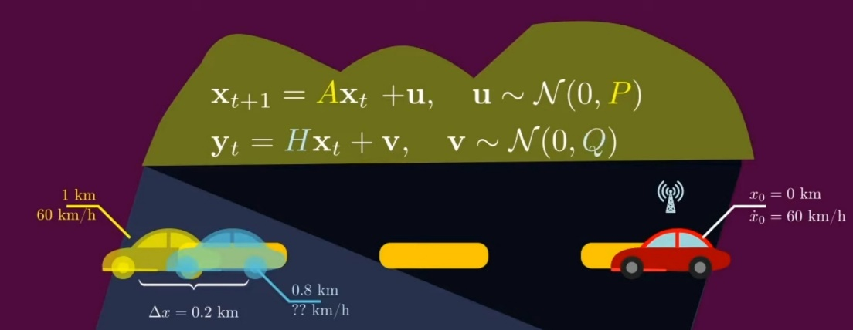

We can explain and Kalman filtre with the help of case study in which we assume a car going at Time T is equals to zero equals zero with a constant speed of 60KILOMETRES per hour for tracking the position and speed of the car and the speed of the car would be constant 60 kilometres per hour according to the simple linear dynamical system.



X(t+1)=1x(t)+ t

X(t+1)=0x(t)+1x(t)

 instance this pedometer that you use noisy measurements of the speed you cheque the manual provided by the manufacturer for the measuring instruments that you use and you find that the measurements that you get are noisy and the noise can be modelled by some Gaussian variable.

Is that the conditions on the road are not good meaning that the nominal dynamical system that governs the movement of the car might get perturbed we like to model this kind of perturbances as Gaussian noise with a known covariance matrix that we call P.

X(t+1)=A(xt)+u ,u~N(0,P)

now an hour has passed what would be your best guess for where the car position is right now and what is your guess for the car speed you could say let me ignore all the imperfections of the word and follow these idealised dynamical system and see where it leads the math in this case the car would remain at the constant speed of 60 kilometre per hour and after one hour it would be one kilometre away from the starting position now all of a sudden you remember something you actually have a gps installed in the car and that gps can give you measurements of the position of the car every hour perfect you cheque the gps data and it’s telling you that the core is 8 kilometre away from the starting position this gps however does not measure the speed of the car so now here is a question which one of these 2 measurements would you trust more the 1 you have predicted by ignoring all the imperfections of the word or the estimate that you obtained from your measuring instruments more interestingly though can you combine both of these estimates to get a new estimate that is more accurate than both estimates individually for instance if you had to guess you would say that the true position of the car is probably between the point 8 and 1 kilometre mark and as a consequence the speed of the car should probably be lower than 60 kilometres per hour but how much less than 60 kilometres per hour and we’re exactly in the interval 0.81 the car’s position is right now as you might have guests the answer probably depends on what we know about the size of the noise in our initial estimates in our measuring instruments in our model of the dynamical system of the car the answer to this question is what Kalman philtres are all about.

Conditions-

XE(0.8,1)

X<60

* X(t+1)=A(xt)+u, u~N(0,P) (dynamically system)
* Y(t)=H(xt)+v, v~N(0,Q) (measured system)

H=[1 0]

* Kalman filtering is a 2 step process here is how it works the first step is called the prediction step in this step whatever prior estimates you had about the state of the system you run these estimates through the idealised version of the dynamical system and that would be a prediction For the state of the system

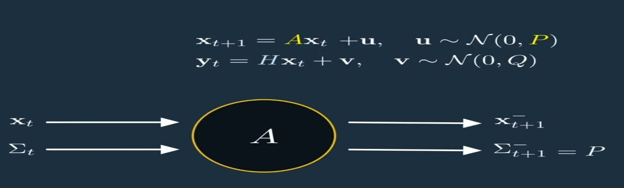

Updating the position involves determining the displacement of the object given the acceleration and velocity.

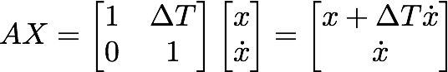

First part of updating matrix X.

When you run the Sigma T from the idealised system And you count the map we have to add an additional term to examine well in the prediction step we simply predict that the car would be in this yellow spot so now the question is how can incorporate the additional information I get from my measuring instrument to update and improve this prediction last five that is that in the second step of Kalman filtering which is appropriately called the update step.



* In the update step we take the results of our prediction in terms of the state of the system and the covariance matrix of the noise and we take the new measurements that we made about the system which are noisy and we combine both in a single estimate which would be our final estimate of the system so to compute is the surprised term the surprise term is the difference between what you have predicted and what you have measured.

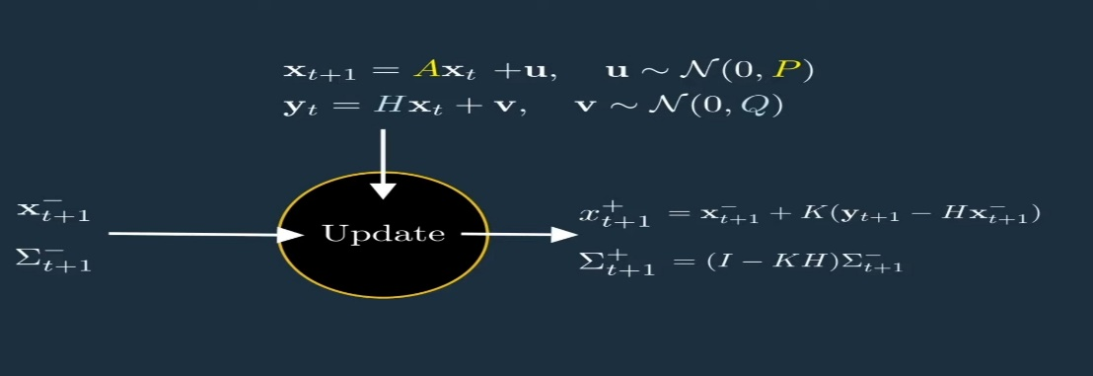

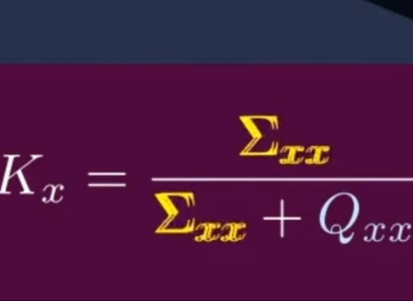

 This update however is applied in Matrix B times u.

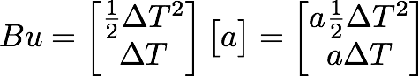

Second part of updating matrix X.

The B matrix mimics part of the kinematics equation where the velocity and acceleration are multiplied by time. When matrix B is multiplied by the control variable (in this case, acceleration) and added to AX, it results in a change to the position and velocity due to acceleration.

A Kalmen ratio the is your uncertainty about your prediction for the position and this Q Term is your uncertainty about the GPS measurements this ratio is always between [-1 to 1].

* it is 0 it means that the sigma term is zero meaning that you have complete fate in the predictions you made so you are basically saying my car is in the yellow spot on the other hand
* it is 1 it means that the Q Term is 0 which means that you completely trust your GPS and you’re saying that the car is in the blue spot



* this ratio will be somewhere between 0 and 1 so the ratio the bigger the bigger is correction.

x (t+1)=x (t+1)+K(x) x



For prediction of the speed of the car –

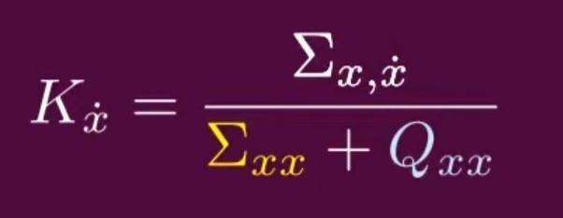

Sigma x*which represents the correlation between speed and position and this makes sense this is the term use to convert an information about the position to any information about the speed.

* In the worst case if the noise in the speed and position are independent from each other this ratio will be zero which means that what we know about the position of the car would be completely useless as far as the speed is concerned and there is an identical formula for correcting our projection for this field more generally going back to the general formula you get the following equations for correcting your predictions for the state of the system and the covariance matrix of the nodes.

Implementation of extended Kalman filter using python-

